John Selders

Pitch Doc

Inspiration: The inspiration for your game could be drawn from classic arcade shoot 'em ups like Space Invaders and R-Type. Also, newer shoot ‘em ups that push the genre to another level known as bullet hells. These games are fast paced and sharpen spatial reasoning. Games titles like Raiden, Battle Garegga, Touho, and Dodonpachi have mastered this art form and design. Sadly, these titles are not as popular today as they were before. My motivation is to revive the nostalgia of these games while adding modern twists and unique features.

Software Solution: This game, titled " Disarraye /Diss-Er-Ray," is a classic shoot 'em up game designed to offer players an adrenaline-pumping experience. It combines the nostalgia of retro shooters with contemporary graphics and innovative power-up mechanics. What sets it apart is a dynamic weapon upgrade system that challenges player's. Disarraye is the ultimate test of reflexes and strategy.

Categorization:

Genre: Shoot 'em Up , Arcade, SHMUP

Platform: Windows PC,

Software Audience: Our target audience is primarily gamers aged 12-45, both male and female, who enjoy action-packed games with a nostalgic touch. This demographic appreciates challenging gameplay and retro aesthetics.

Revenue Model: We plan to offer a free-to-play version with in-game ads. The ads will be based on indie developments that need more promotion. The premium version, priced at $4.99, will include an ad-free experience and exclusive in-game content.

Team:

John Selders (Lead Developer - Backend and Gameplay Mechanics)

Member #2 (UI/UX Designer)

Member #3 (Sound Engineer and Music Composer)

Comparable Products:

Zero Ranger: Zero Ranger is known for its captivating story and innovative gameplay mechanics. While it offers a unique experience, “Dissraye” aims to stand out with its dynamic weapon upgrade system, which allows players to customize their playstyle more extensively.

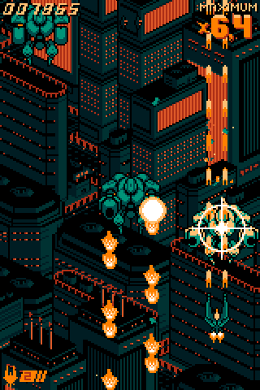



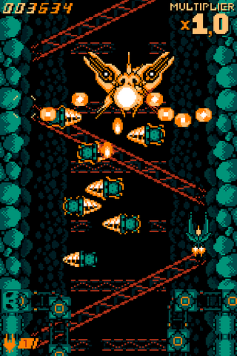

Visual Representation Examples:

DRAINUS: DRAINUS is praised for its intense and challenging shoot 'em up gameplay. “Disarraye” will offer a similar level of challenge but will differentiate itself through a captivating storyline and a diverse range of power-ups.

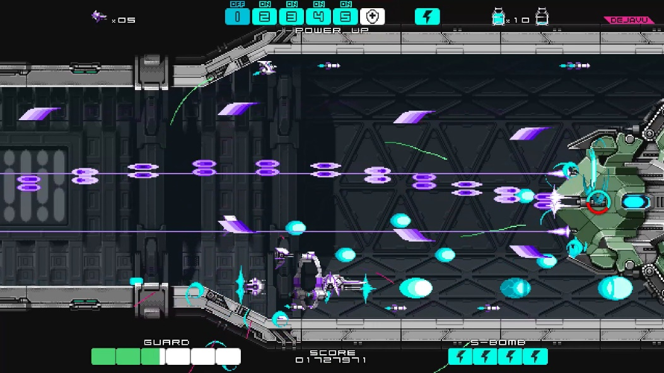

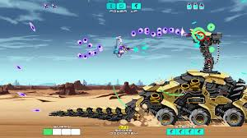

: Crimzon Clover is admired for its fast-paced action and stunning visuals. “Disarraye” will aim to match its visual appeal while introducing a more personalized gameplay experience through its weapon upgrade system.

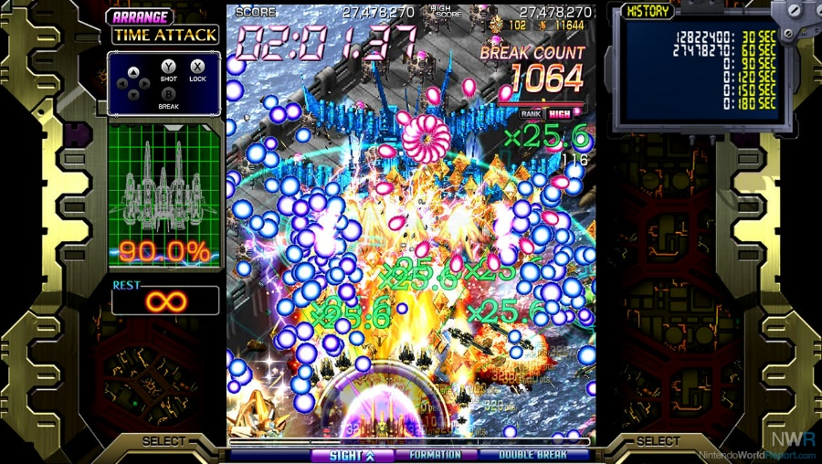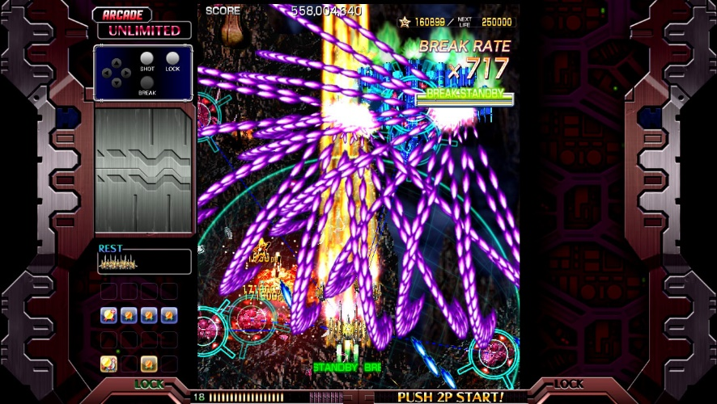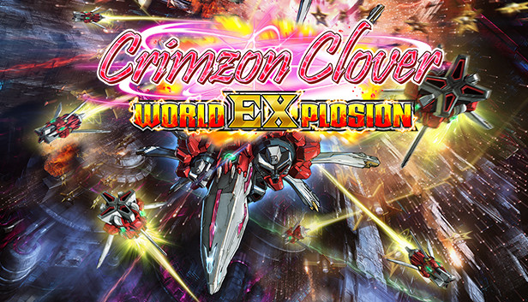

Feature List:

A Features

* Classic Shoot 'em Up Gameplay: Implement the core mechanics of a traditional shoot 'em up, including player movement, shooting, and enemy waves.
* Dynamic Weapon Upgrade System: Develop a system that allows players to collect power-ups and customize their ship's weapons based on their playstyle.
* Multiple Difficulty Levels: Include easy, medium, and hard difficulty settings to cater to a broad range of players.
* Multiplayer Mode: Enable cooperative or competitive multiplayer gameplay to enhance the social aspect.

B Features (Bonus):

* Leaderboards and Achievements: Add leaderboards to encourage competition among players and achievements for completing specific challenges.
* Daily Challenges and Events: Introduce daily challenges and special in-game events to keep players engaged over time.
* Customizable Player Ships: Allow players to customize their ships' appearance and attributes beyond the core upgrades.
* In-game Ads (Free Version): Implement non-intrusive advertisements in the free version of the game.
* Premium Version: Develop a premium version of the game priced at $9.99, which offers an ad-free experience and exclusive in-game content.

C Features (Bells and Whistles):

Online co-op: This will take more time understanding the delayed based netcode. There is one in mind call GGPO but will require more time.

In-game Tournaments: Organize in-game tournaments or events with special rewards for participants.